GDS-68S2XP Installation Best Practices &Worksheet
Installation Guidelines / Best Practices
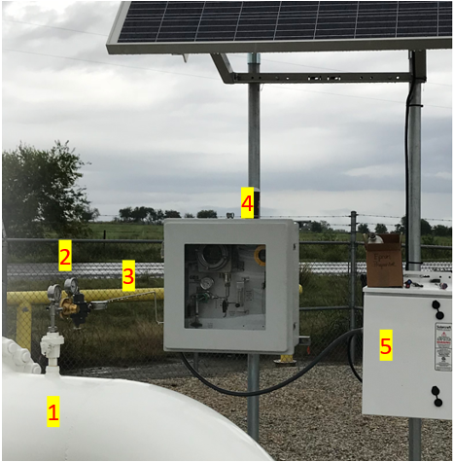
- Make sure unit has clean & reliable source of +24DC power.

- Protect unit from direct sunlight as much as possible.

- Use an external regulator to reduce sample line pressure to between 10 and 25 PSIG

- Keep sample line less than 25’ of ¼” OD stainless steel tubing

- Use a sample probe to acquire sample from middle of pipe. Make sure that sample extraction point is installed in main flow and not stub or inactive line

Installation Worksheet
- What is the target odorant & expected concentration? ______________________
- Describe condition of target gas________________________________________
- What is the power source (Batteries, AC power, Solar, etc.)?_________________
- Is H2S present in the gas stream? (Y/N) and does this need to be ignored or included in measurement? ____________________________________________
- What are the highest / lowest ambient temperatures expected? _______________
Please contact GDS Corp prior to installation if you have any questions or concerns regarding a specific situation. GDS Corp will not be responsible for damage or incorrect readings due to improper installation.
I have reviewed the GDS-68S2XP User’s Manual and Installation Guidelines shown above and understand the recommended installation best practices.
Name: __________________________________________________________
Signature: _______________________________________________________
Date: ___________________________________________________________

